Automated Client On-boarding & Invoicing Pipeline

# Automation Title

Automated Client On-boarding & Invoicing Pipeline

# Category

Operations, Finance & Customer support

# Image/Thumbnail

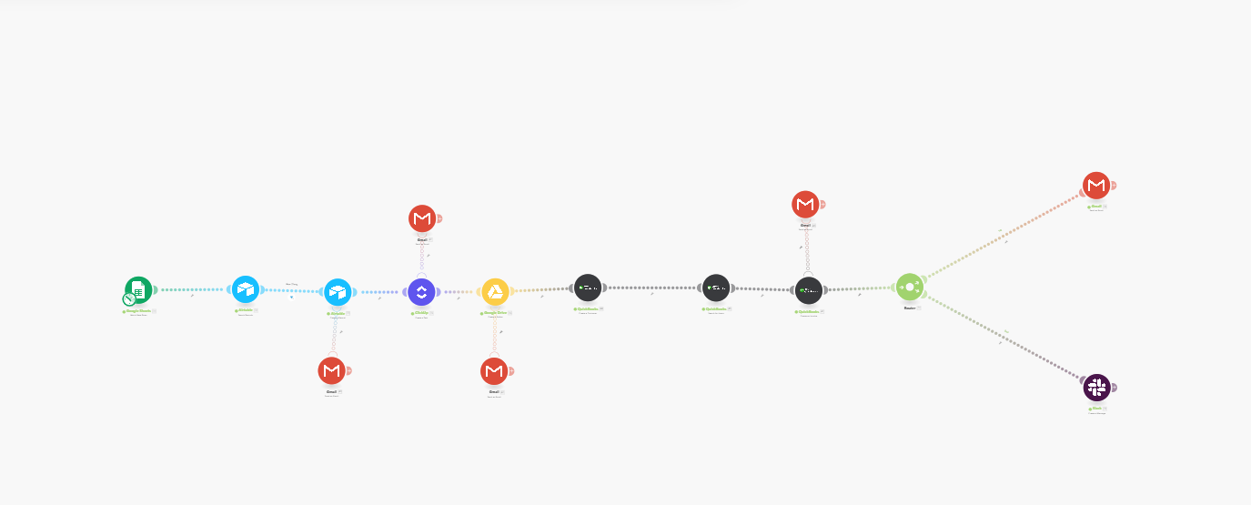

# Size of Project

Medium

# Version & Updates

v1.0 – Initial release with integrated QuickBooks Invoicing and robust error handling.

# Detailed Description

This automation addresses the common operational challenge of slow and error-prone client on-boarding that bridges front-end sales data (from a form/spreadsheet) directly into core business systems (CRM and Financials). It is designed for operations managers and finance teams who need to ensure compliance, proper file management, and immediate revenue tracking upon client sign-up.  
  
The primary business problem solved is the time delay and risk of revenue leakage caused by manual data entry. Before this automation, a team member would manually take client data, create a record, set up a shared folder, create a customer profile in QuickBooks, look up the service item, and manually draft the invoice. This process could take 30 minutes per client and was susceptible to data entry mistakes.  
  
The solution automates 90% of this workflow instantly upon receiving the initial client data. It ensures the customer is created in QuickBooks, the correct service item is referenced using its unique ID, the draft invoice is generated, the client receives a professional welcome email with all necessary links, and a dedicated error route alerts management if any step fails. The result is instant, error-free financial setup and a professional client experience.

# How It Works (Functionality)

This work-flow is triggered by new client data and contains multiple steps, including a critical error handling route for reliability:  
  
Trigger: Google Sheets (Watch New Rows): Detects a new row (client submission) in the specified Google Sheet, which inturn receives data submitted by the customer from a Google form. This module watches for new data from the Google sheet every 15 minutes  
  
Action 1: CRM Update (Airtable): Creates a record in the designated client Airtable Base using the new client data. A filter is first applied using email to check for old clients, new records are not created on Airtable for old clients.  
  
Action 2: Project Setup (Google Drive): Creates a dedicated project folder for the client using name and email.  
  
Action 3: Customer Creation (QuickBooks): Creates a new customer profile in QuickBooks using the client's name and email. Output: Generates the unique Customer ID.  
  
Action 4: Service Lookup (QuickBooks Search for Item): Executes a User-Defined Query (SELECT * FROM Item WHERE Name = 'Your Service Name') to retrieve the unique Item ID for the service being billed.  
  
Action 5: Draft Invoice (QuickBooks Create a Draft Invoice):  
  
- Maps the Customer ID (from Step 4) to the nested CustomerRef field.  
- Maps the Item ID (from Step 5) to the required line item reference.  
- Sets the line item Type to 'Services' and enters the fixed Amount.  
  
Output: Success Email (Gmail Send an Email): Sends an HTML-formatted welcome email to the client, confirming the project status and providing links to the new Drive folder.

Also sends a notification message on slacks informing the team about a new project from a new customer, and a call to action.  
  
Error Handler Route: If any critical module (especially Airtable or QuickBooks) fails, a separate route is triggered:  
  
Gmail (Send an Email): Sends an alert to the operations manager containing the full client data, the failed module's name, and the exact error message (e.g., Missing value of required parameter 'CustomerRef').

# Tools Required

Platform: Make (formerly Integromat)  
  
Data Source: Google Sheets, Google forms  
  
CRM : Airtable  
  
File Management: Google Drive  
  
Financials: QuickBooks (Online)  
  
Communication: Gmail, Slack

# Setup Requirements

QuickBooks Connection: Requires OAuth connection. The automation depends on a pre-existing Service/Item in QuickBooks with a known, fixed name for the Search for Item query.  
  
Google Credentials: OAuth connection for both Google Sheets and Google Drive.  
  
Airtable: API key and Base/Table ID.  
  
Critical Mappings: Correct mapping of nested reference fields (CustomerRef and Item ID) using the ID outputs from the upstream QuickBooks modules.

# Deployment Time Estimate

Estimated Time: 4–6 Hours (Includes API setup, configuring the complex nested mappings in QuickBooks, and running end-to-end testing with error handler validation).

# Value Proposition

Metric:  
  
Estimate:  
  
Assumptions: This setup assumes a fixed quantity (e.g., 1) and fixed price (1000000) entered directly into the module for each service request from the customer. For variable pricing, the Amount field must be mapped to a clean number variable from the Google Sheet.

It also assumes the entire project team members has been added to Slack  
  
Time Saved per Client: 29 minutes (Manual process takes 30 min, automation takes 1 min.)  
  
Hours Saved / Month: 4.8 hours (Based on 10 client onboardings per month.)  
  
Approximate Cost Savings / Month: $192 (Based on an employee rate of $40/hour).

# Known Limitations

Service Name: The Search for Item module requires the service name in the query to exactly match the name in QuickBooks (case-sensitive).  
  
API Complexity: The QuickBooks module requires mapping the unique ID to a nested field (CustomerRef > ID), which can be tricky to configure.  
  
Quantity/Pricing: Each run on make may cost between 10-20 credits, thus if the setup is set to run every 15 minutes, this might consume a lot of credits in the long run.

# Estimated ROI

Estimated Monthly Savings: (4.8 hours saved × $40/hour employee rate) = $192  
  
Subscription Costs: (Estimate based on Make core plan) ≈ $9  
  
Estimated Monthly ROI: $183 (Excluding intangible benefits of error reduction and speed)